Equipment needed for Night Photography www.theschoolofphotography.com/tutorials/settings-for-night-photography
- You’ll need a camera that goes into full manual mode. This will enable you to take full control over the camera settings. An easy way to check if your camera has this function is to look at the top of the camera and see if it has a dial with the letter M (for manual) on it. If yours has this, it will be fine for photographing the night.
- A standard zoom lens is fine for this type of photography but if you have one, an ultra-wide-angle lens will enable you to get those vast stretched out scenes of bridges over water and alike.

- You will need a good sturdy tripod to take the weight of your camera. As it’s dark, exposure times shooting the night sky will be long, therefore your camera needs to be dead still. Avoid using cheap flimsy tripods as these could cause your camera to move in the wind or make your set up top heavy.
- Whist your taking pictures during night photography you cannot touch the camera as you will get camera shake. To enable this you will need a remote trigger or a cable release, this will enable you to fire off the camera without touching it.

- Although not necessary, it’s a good idea to use what’s called an ultra-wide angle lens.

Night Photography Camera Settings
- M – Manual mode.
- Shutter Speed – 30 to 60 seconds. As it’s dark, a longer shutter speed will give enough time to let a lot of light to enter the camera. If you find your photography coming out too dark, increase the time, if your photos are coming out too light, decrease the time.
- Aperture – f8, f11 or f 16. This is to create what’s called a long depth of field and allows you to create an image that is sharp from the foreground to the background. As with the shutter speed, you can make your shots lighter or darker with the aperture. Start at f11 and if the image is too light, go to f16, if it’s too dark, go to f8.
- ISO – 100 or 200. This is to reduce noise. Noise in an image creates a speckly look with dull colours. To get a clean crisp and colourful night photograph, you will need as little noise as possible.
- Set White Balance to Auto. Night photography usually has lots of different light sources with lots of different colours. Shooting in Auto White Balance gives you a good middle ground which can be adjusted as needed back in post-processing programs like Lightroom. Another option is to set the camera’s white balance to Daylight. This will capture colours as they are, but I find the photos come out too orange when doing it this way.
- Manual Focus. As it going to be dark, your camera will find it hard to focus onto something. To tackle this, focus onto something lit in the distance, then switch lens to manual focus to fix the focus point.
- Shoot in Raw. This is optional but highly advised. Shooting in Raw will give you much more scope when, or if, you post-process the shot. Further details below.

Camera Settings for light trails https://expertphotography.com/light-trails-photography/
The best camera settings for light trails photography are the following.
- Shoot in RAW;
- Choose the lowest ISO values;
- Set your aperture to the sweet spot of your lens, in the f/4 to f/11 range;
- Use a shutter speed of about 10-30 seconds.
Test your settings and check whether you get trails of a decent length. Also, check that you have not clipped the highlights to pure white. You want to keep some colours in the trails and avoid patches of pure white that are not pleasant to see.

Camera Settings for Bridges at night https://www.exposureguide.com/cityscape-photography-tips/

Bridges that are lit up at night look stunning when photographed well. Once again, place your camera on a tripod and position it so that the bridge, the water and buildings can be seen; we want interest in the foreground and background.
Set the mode dial to aperture priority mode, and choose an aperture of f/16 or more. Ideally, we want a long exposure anywhere between 1-30 seconds for a silky water effect. For warmer colors set the White Balance from Auto to Daylight.
Because you are on a tripod, it is good practice to disable image stabilisation. The exception to this are bridges or similar “floating” structures. Passing traffic can create vibrations here that will cause camera shake and ruin your image. Experiment with long exposure noise reduction. This will tell you whether you should keep it active or not. This will allow your light streak photography to be sharp and not blurry. Be aware that the camera will take a second photo. This will be for the same amount of time without opening the shutter when you use this technique. It happens immediately after the first picture.

How Do you Focus the Milky Way in Photography? Focusing on the Milky Way is super simple. https://expertphotography.com/milky-way-photography-settings/
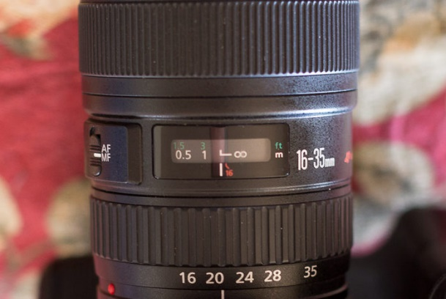
All you need to do is to set your focus at infinity. This looks like the figure-eight symbol in the image below.
On Canon cameras, you want to line up the little sideways L with the line to focus on infinity. On other cameras, you’ll want to align the infinity symbol with the line. Always check to see how it works on your lens.
Once you’ve set your focus to infinity, turn your focus mode to manual. This way, your camera won’t try to refocus in the dark when you go to take a photo. It will not do a good job!
Remember also to check your focus every time you recompose your shots. It’s very easy to knock the focus ring and send your photo into a blur. If you’re not sure if your marking is accurately placed, check it in daylight. Focus to infinity using live view, and see if the signs line up.
If you don’t have a focus scale on your lens, use manual focus with the help of live view magnification. Be warned, it’s not an easy task in the dark!.

In-Camera Long Exposure Noise Reduction
A useful but time-consuming function of digital cameras is In-Camera Long Exposure Noise Reduction.
The camera does this by first taking a regular 30-second exposure. Once that’s captured, the camera will close the shutter and capture another 30-second ‘blank’ exposure. The camera will then compare the blank exposure to the original photo. It does this to identify the digital noise, and then remove it from the original photo.
And it does a pretty good job!
But as with everything to do with exposure, there is one major downside: time.
This process is very time consuming and will drain your battery life, so it’s not perfect. If you’re taking many photos for a panorama, it won’t be quick enough to capture photos without the stars moving too much to stitch together later.

Conclusion: Our Go-To Settings
So, what settings do you use to shoot the Milky Way? These are the settings we use for 98% of our Milky Way photography.
These are specific to our gear. Once you’ve worked out the settings for your equipment, you’ll find that you can use the same settings for most of your shots.
Here they are:
- Focal Length: 14mm (on a full-frame sensor)
- Aperture: f/2.8
- Shutter Speed: 30 seconds
- ISO: 3200
- Focus: Manually set to infinity
- In-Camera Long Exposure Noise Reduction: Off

